Capstone Report

Jackson McKeigue
AI 5273: AI Capstone Project
Carlos A. Escobar
5/2/26

Introduction & Problem Statement
Pneumonia remains a leading cause of morbidity and mortality worldwide, particularly among vulnerable populations such as young children, older adults, and immunocompromised individuals (World Health Organization [WHO], 2023). Early and accurate diagnosis is essential for effective treatment; however, the interpretation of chest radiographs requires specialized expertise and is subject to variability across clinicians. In many healthcare environments, especially those with limited access to trained radiologists, diagnostic delays and inconsistencies can negatively impact patient outcomes.
Advances in artificial intelligence (AI), particularly deep learning, present a promising opportunity to address these challenges. Convolutional neural networks (CNNs) have demonstrated strong performance in medical image classification tasks, including the detection of thoracic diseases from chest X-ray images (LeCun et al., 2015; Rajpurkar et al., 2017). These systems can identify complex visual patterns that may not be immediately apparent to human observers, enabling faster and potentially more consistent diagnostic support.
The central problem addressed in this capstone project is the development of a robust, interpretable, and ethically responsible AI system capable of detecting pneumonia from chest X-ray images. The project aims not only to achieve strong predictive performance but also to ensure that the system operates effectively within a clinical decision-making context. Rather than replacing clinicians, the proposed system, MedScanAssist, is designed to function as a decision-support tool that enhances diagnostic workflows, improves efficiency, and supports more informed clinical judgments.

Literature Review Summary
Recent research in medical imaging has demonstrated the effectiveness of deep learning models, particularly CNNs, in diagnosing diseases from radiographic data. CNN architectures are well suited for image-based tasks because they automatically learn hierarchical feature representations, allowing them to identify patterns such as lung opacities and structural abnormalities associated with pneumonia (LeCun et al., 2015).
One of the most influential studies in this domain, CheXNet, showed that a deep CNN (DenseNet-121) could achieve performance comparable to radiologists in detecting pneumonia from chest X-rays (Rajpurkar et al., 2017). This work established a strong foundation for the use of transfer learning in medical imaging, where pretrained models leverage knowledge from large-scale datasets to improve performance on smaller, domain-specific datasets (Pan & Yang, 2010).
Despite these advancements, significant challenges remain in translating AI models into real-world clinical settings. One major concern is generalizability. Models trained on a single dataset may fail to perform consistently across different hospitals due to variations in imaging equipment, patient demographics, and clinical practices (Kelly et al., 2019). This issue, often referred to as domain shift, highlights the importance of robust evaluation strategies such as cross-validation and external dataset testing.
Another critical challenge is interpretability. Deep learning models are often considered “black boxes,” making it difficult for clinicians to understand how predictions are generated. To address this, techniques such as Gradient-weighted Class Activation Mapping (Grad-CAM) have been introduced to provide visual explanations by highlighting regions of an image that contribute most to the model’s prediction (Selvaraju et al., 2017). However, recent studies emphasize that explainability methods must be carefully evaluated, as models may rely on spurious correlations rather than clinically relevant features (Ghassemi et al., 2021).
Ethical considerations also play a central role in medical AI development. Bias in training data can lead to unequal performance across demographic groups, potentially reinforcing healthcare disparities (Ghassemi et al., 2021). Additionally, overreliance on AI predictions by clinicians may reduce critical oversight, increasing the risk of diagnostic errors (Kelly et al., 2019). These concerns highlight the need for AI systems that are not only accurate but also transparent, fair, and aligned with established ethical frameworks.
Overall, the literature supports the potential of AI in medical imaging while emphasizing the importance of robust evaluation, interpretability, and ethical design. These insights directly inform the development of MedScanAssist and guide its design as a responsible clinical decision-support system. More specifically, the literature shaped three major design decisions in MedScanAssist. First, prior work on CNN-based chest X-ray classification supports the use of transfer learning rather than relying only on a custom CNN trained from scratch. Because medical imaging datasets are often limited, imbalanced, or institution-specific, pretrained architectures such as DenseNet and ResNet provide a stronger starting point for feature extraction and reduce the risk of overfitting. Second, research on domain shift and clinical AI implementation supports the project’s emphasis on cross-validation, external dataset testing, and subgroup performance analysis. These methods help evaluate whether the model performs reliably beyond the dataset on which it was trained. Third, concerns about black-box decision-making justify the integration of Eigen-CAM visual explanations as a required part of the system rather than an optional add-on. In this way, the literature does not simply support the topic of pneumonia detection; it directly informs the model architecture, evaluation strategy and ethical safeguards used throughout the project.

Conceptual Project Design
The MedScanAssist system is designed as a deep learning-based clinical decision support tool that processes chest X-ray images and outputs a probability score indicating the likelihood of pneumonia. The system follows a structured pipeline that integrates data preprocessing, model inference, explainability, and user interaction.
At the core of the system is a convolutional neural network trained using transfer learning. Pretrained architectures, DenseNet and ResNet, are used to improve performance and training efficiency by utilizing feature representations learned from large-scale image datasets (Pan & Yang, 2010). Fine-tuning these models allows the system to adapt to domain-specific patterns present in chest radiographs while reducing the risk of overfitting associated with smaller medical datasets.
The pipeline begins with image ingestion, where chest X-ray images are uploaded into the system. These images undergo preprocessing steps, including resizing to a standardized resolution, normalization of pixel intensities, and data augmentation techniques such as rotation and flipping. These steps are essential for improving model generalization and ensuring compatibility with pretrained network architectures.
Following preprocessing, the image is passed through the CNN for feature extraction and classification. The model outputs a probability score representing the likelihood of pneumonia, rather than a binary classification. This design choice reinforces the system’s role as a decision-support tool by providing clinicians with interpretable confidence levels rather than definitive diagnoses.
To enhance transparency, MedScanAssist incorporates Eigen-CAM visualization, which highlights regions of the X-ray that influence the model’s prediction. This allows clinicians to assess whether the model is focusing on clinically relevant areas, such as lung regions, rather than irrelevant artifacts. By combining probabilistic outputs with visual explanations, the system supports informed clinical decision-making while maintaining human oversight. The system is designed for deployment as a web-based application, enabling users to upload images, view predictions, and analyze model explanations through an intuitive interface. Backend functionality is supported through a containerized environment, ensuring reproducibility and scalability across different deployment settings.
Figure 1
Example MedScanAssist interface showing prediction output, confidence score, and Eigen-CAM visualization with attention distribution metrics.
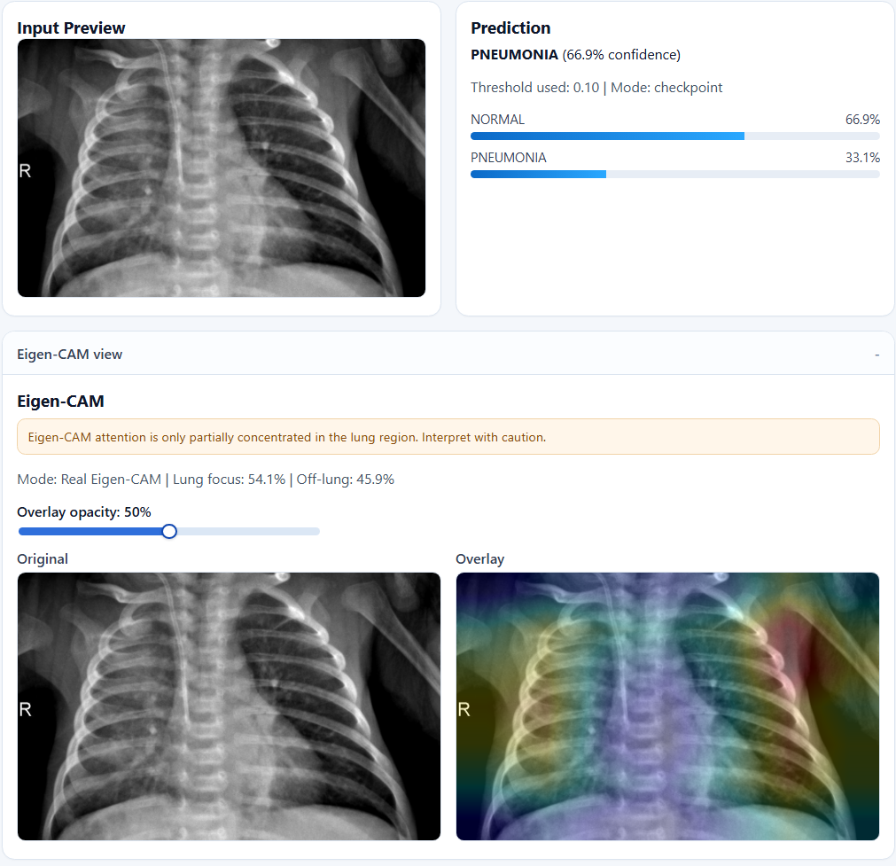
Figure 1 illustrates a real example of the MedScanAssist interface, highlighting how prediction outputs are presented alongside Eigen-CAM visual explanations. In addition to displaying classification confidence, the system provides attention distribution metrics, such as lung focus and off-lung attention percentages, as well as cautionary warnings when attention is not fully concentrated in clinically relevant regions. This design reinforces transparency by allowing clinicians to evaluate not only the model’s prediction but also the reasoning behind it, supporting more informed and responsible decision-making.
The conceptual design of MedScanAssist reflects a balance between technical performance, usability, and ethical responsibility. The system integrates established deep learning methodologies with explainability and user-centered design principles, positioning it as a practical and responsible prototype for AI-assisted pneumonia detection. The overall system architecture is illustrated in Figure 1, which outlines the full pipeline from image input to model output and monitoring.
The design also reflects lessons learned from the working MedScanAssist prototype. While earlier development phases of the project focused more heavily on implementation details such as model comparison, calibration curves, API endpoints, and deployment architecture, the capstone version uses those technical components to support a broader responsible AI framework. For example, the use of DenseNet and ResNet is not only a performance decision but also a feasibility decision, since transfer learning is more appropriate for limited medical imaging data. Similarly, the probability output, Eigen-CAM visualization, and monitoring loop are included because they support clinician interpretation, reduce the risk of overreliance, and create a path for continuous improvement. This distinction helps separate the capstone report from the earlier technical development phases while still showing that the proposed system is grounded in an actual prototype.
Figure 2
MedScanAssist System Pipeline illustrating data preprocessing, model inference, explainability, and monitoring components.
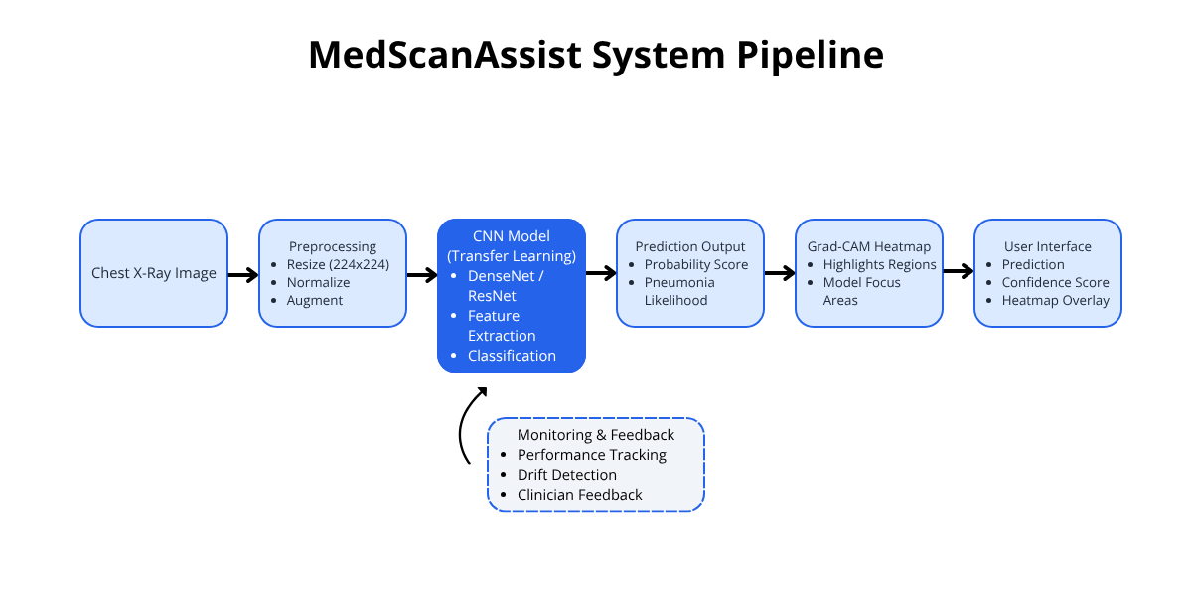

Stakeholder Needs
Several stakeholder groups shape the requirements for MedScanAssist. Clinicians and radiologists need outputs that are interpretable, clinically relevant, and clearly presented so that AI can support rather than override professional judgement. Patients need the system to be safe, fair, and reliable across diverse populations because diagnostic errors can directly affect treatment decisions. Healthcare organizations need a tool that can improve workflow efficiency without introducing excessive false positives, privacy risks, or operational burden. Technical developers need reproducible training, deployment, and monitoring processes so that the model can be evaluated and improved responsibly. Finally, regulatory and governance stakeholders require documentation, transparency, and evidence that the system aligns with accepted AI risk management principles. These stakeholder needs influence the system’s emphasis on probability scores, explainability, human oversight, performance monitoring, and clear communication of limitations.

Ethical Impact Summary
While the conceptual design defines how MedScanAssist functions technically, it also introduces important ethical considerations that must be addressed to ensure responsible use in clinical environments. While AI systems have the potential to enhance diagnostic efficiency, they also carry risks related to bias, transparency, and unintended clinical consequences.
One of the primary ethical concerns is algorithmic bias. Medical imaging datasets often lack demographic diversity, which can lead to unequal model performance across different patient populations. If the training data overrepresents specific age groups, geographic regions, or imaging conditions, the model may generalize poorly to underrepresented groups. To mitigate this risk, MedScanAssist incorporates strategies such as cross-validation, external dataset evaluation, and subgroup performance analysis where possible. These practices align with broader recommendations for fairness auditing in medical AI systems (Ghassemi et al., 2021).
Transparency and explainability are also critical components of ethical AI design. Deep learning models are frequently criticized for functioning as “black boxes,” which can limit clinician trust and hinder adoption. To address this, MedScanAssist integrates Eigen-CAM, a gradient-free class activation mapping technique to visually highlight the regions of an X-ray that influence the model’s prediction. Additionally, the system presents probability scores rather than binary outputs, allowing clinicians to interpret model confidence and incorporate it into their decision-making process.
Another significant concern is the risk of overreliance on AI systems. Studies have shown that clinicians may place excessive trust in automated predictions, particularly when models demonstrate high accuracy (Kelly et al., 2019). In response, MedScanAssist is explicitly designed as a decision-support tool rather than an autonomous diagnostic system. Human oversight remains central to the diagnostic process, and the system is intended to augment, not replace, clinical judgement.
Data privacy and security must also be considered, as medical images contain sensitive patient information. Although this project operates within a simulated environment using publicly available datasets, any real-world deployment would require strict adherence to privacy regulations such as the Health Insurance Portability and Accountability Act (HIPAA). Secure data handling, anonymization, and encryption would be essential components of a production system.
Finally, MedScanAssist aligns conceptually with established ethical and regulatory frameworks, including the National Institute of Standards and Technology (NIST) AI Risk Management Framework and the OECD AI Principles. These frameworks emphasize fairness, accountability, transparency, and safety throughout the AI lifecycle. By incorporating these principles into system design, evaluation, and monitoring, MedScanAssist demonstrates a commitment to responsible AI development.
This alignment can be understood through the lifecycle structure of the NIST AI Risk Management Framework. In the “map” stage, MedScanAssist identifies clinical risks such as false negatives, dataset bias, and overreliance on automated outputs. In the “measure” stage, the system evaluates performance using sensitivity, specificity, ROC-AUC, calibration, subgroup analysis, and explainability review. In the “manage” stage, risks are addressed through threshold calibration, human-in-the-loop review, external validation, drift monitoring, and clinician feedback. The project also reflects the OECD AI Principles by emphasizing human-centered design, accountability, transparency, and robustness. These frameworks help position MedScanAssist as a responsible decision-support prototype rather than a stand-alone diagnostic authority.

Evaluation Framework & Metrics
Building on these ethical considerations, the evaluation framework is designed not only to measure model performance but also to assess fairness, transparency, and real-world reliability.
For this project, success is defined by more than a single accuracy score. A successful MedScanAssist system should demonstrate strong sensitivity for pneumonia detection, balanced precision and recall, high ROC-AUC, and probability outputs that are well calibrated enough to support clinical interpretation. The system should also show evidence of robustness through cross-validation and, where possible, external dataset testing. From an ethical perspective, success requires that performance be evaluated across available subgroups, that Eigen-CAM explanations focus on clinically meaningful lung regions, and that the interface communicates uncertainty clearly. These success criteria reflect the system’s intended role as a clinical decision-support tool rather than an autonomous diagnostic system.
From a performance standpoint, the primary focus is on clinically relevant classification metrics. Sensitivity (recall) is prioritized because false negatives, missed pneumonia cases, can have serious consequences for patient outcomes. Specificity is also important for controlling false positives and minimizing unnecessary follow-up procedures. Additional metrics such as precision and F1-score provide a balanced view of model performance, while Area Under the Receiver Operating Characteristic Curve (AUC-ROC) evaluates the model’s ability to distinguish between classes across different decision thresholds.
A key component of the evaluation framework is threshold calibration. Instead of using a default classification threshold, MedScanAssist adjusts the decision boundary to align with clinical priorities. For example, the threshold may be tuned to maximize sensitivity while maintaining acceptable specificity, ensuring that high-risk cases are not overlooked. This approach reflects the asymmetric cost of errors in medical diagnosis and aligns with best practices in clinical AI evaluation (Kelly et al., 2019).
Figure 3
MedScanAssist dashboard demonstrating monitoring, prediction history, and clinician feedback integration.
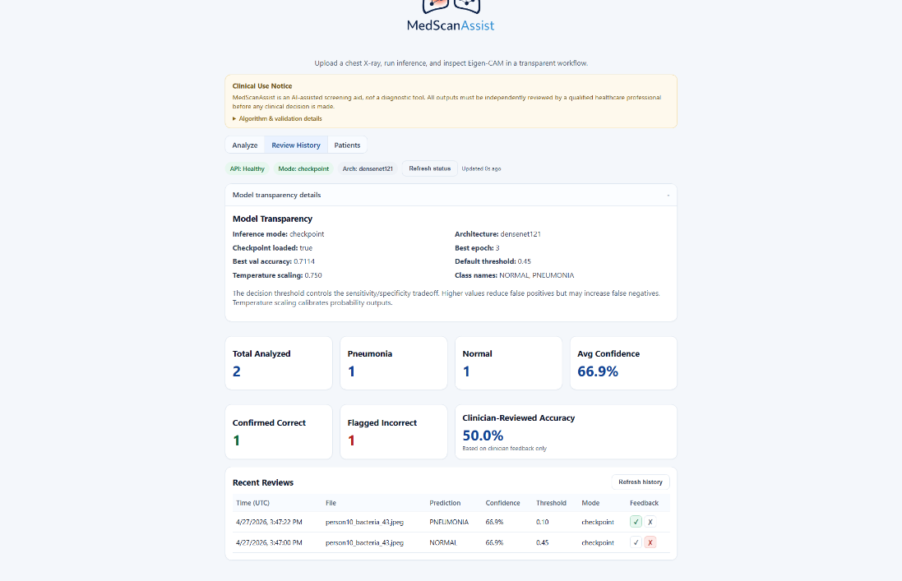
Figure 3 demonstrates the broader MedScanAssist interface, including monitoring metrics, prediction history, and clinician feedback integration. These components reflect the system’s emphasis on continuous evaluation and human-in-the-loop learning. By tracking prediction outcomes and incorporating feedback, the system supports ongoing refinement and aligns with best practices of AI lifecycle management.
Beyond classification performance, probability calibration is also assessed to ensure that predicted confidence scores accurately reflect true likelihoods. Poorly calibrated models may produce overconfident predictions, which can mislead clinicians and increase the risk of overreliance. Calibration techniques, such as temperature scaling, are incorporated to improve the reliability of probability outputs.
Fairness is evaluated through subgroup performance analysis, where model metrics are compared across different demographic or clinical subgroups when data is available. This helps identify potential disparities in model performance and supports efforts to mitigate bias. Additionally, external validation using datasets from different sources is considered to assess generalizability and robustness across varying clinical environments.
Transparency is assessed using explainability techniques such as Eigen-CAM. Evaluation includes not only the presence of visual explanations but also whether the model is focusing on clinically relevant regions of the image. This helps ensure that predictions are based on meaningful patterns rather than spurious correlations.
Finally, usability is considered as part of the evaluation framework. The system’s interface is designed to present predictions, confidence scores, and visual explanations in a clear and interpretable manner. This supports effective integration into clinical workflows and enhances the practical value of the system.
Risk mitigation is integrated directly into the evaluation plan. False negatives are addressed by prioritizing sensitivity and tuning thresholds to reduce missed pneumonia cases. False positives are managed by monitoring precision and specificity so the system does not create unnecessary clinical burden. Dataset bias and domain shift are addressed through cross-validation, external validation, and subgroup analysis when demographic metadata is available. Overreliance is reduced by presenting probability scores and Eigen-CAM visualizations instead of definitive diagnostic commands. Finally, performance drift is addressed through monitoring and feedback loops that allow future model updates when incoming data begins to differ from training data. These strategies ensure that evaluation is not limited to model scoring but also supports responsible clinical risk management.
Together, these evaluation dimensions provide a comprehensive framework for assessing MedScanAssist. By combining statistical performance metrics with considerations of fairness, transparency, and usability, the evaluation strategy reflects the broader goal of developing a reliable and responsible clinical decision-support system.

Leadership & Communication Strategy
Beyond technical performance and evaluation, the successful implementation of MedScanAssist depends on effective leadership and communication across stakeholders. AI systems in healthcare operate within complex environments where trust, transparency, and collaboration are critical to adoption. As a result, leadership in this project focuses on aligning technical development with stakeholder needs while ensuring clear communication of system capabilities and limitations.
One of the primary leadership challenges in this project is stakeholder alignment. Different groups, including clinicians, healthcare organizations, and technical developers, have distinct priorities and expectations. Clinicians require interpretable outputs and must maintain control over diagnostic decisions, while healthcare organizations prioritize efficiency and workflow integration. Technical teams, on the other hand, focus on model performance and system scalability. Addressing these competing priorities requires a collaborative leadership approach that emphasizes shared goals and continuous feedback.
To manage this challenge, MedScanAssist adopts a human-centered communication strategy. For clinicians, the system emphasizes interpretability through probability scores and Eigen-CAM visualizations, allowing users to understand and validate model predictions. For healthcare organizations, communication focuses on operational benefits such as improved triage efficiency and reduced diagnostic bottlenecks. For technical stakeholders, detailed documentation and performance metrics provide transparency into model behavior and limitations.
Another key leadership consideration is managing expectations around AI capabilities. It is essential to clearly communicate that MedScanAssist is a decision-support tool rather than a replacement for clinical expertise. Overstating the capabilities of AI systems can lead to overreliance and misuse, while under-communication can reduce adoption. Transparent messaging, particularly regarding model limitations, uncertainty, and potential risks, helps build trust and support responsible use.
Communication must also be tailored to the level of technical knowledge and responsibility of each stakeholder group. Clinicians should receive concise explanations of probability scores, model limitations, and Eigen-CAM outputs so they can use the system without treating it as a substitute for medical judgement. Patients should receive plain-language explanations that the tool supports clinicians but does not independently diagnose disease. Healthcare administrators should receive information about workflow impact, risk controls, and governance requirements. Technical stakeholders should receive detailed documentation of model performance, calibration, monitoring, and known limitations. By adapting communication to each audience, MedScanAssist supports trust while reducing the risk of misunderstanding or misuse.
Additionally, the project incorporates a feedback-driven development approach. Clinician feedback mechanisms allow users to flag incorrect predictions, creating a human-in-the-loop system that supports continuous improvement. This iterative process not only enhances model performance over time but also strengthens stakeholder engagement by involving users directly in system refinement.
Overall, the leadership and communication strategy for MedScanAssist emphasizes collaboration, transparency, and adaptability. By aligning technical development with stakeholder needs and maintaining clear, honest communication, the project supports both effective implementation and responsible AI use in a healthcare setting.

Integrated Flow Diagram (System Pipeline Description)
Figure 1 presents the integrated MedScanAssist pipeline from image upload through preprocessing, model inference, explainability, clinician review, and monitoring. The purpose of the diagram is not only to show the technical flow of data but also to demonstrate how ethical checkpoints and evaluation considerations are embedded throughout the system. Bias and fairness concerns are addressed during dataset selection, preprocessing, and subgroup evaluation. Transparency is addressed through probability outputs and Eigen-CAM visualization. Clinical safety is addressed through human-in-the-loop review, threshold calibration, and feedback mechanisms. This integrated structure reflects the full lifecycle of a responsible AI system rather than a one-time model prediction process.
The process begins with the input stage, where a chest X-ray image is uploaded into the system. This image is then passed through a preprocessing stage, which includes resizing to a standardized resolution, normalization of pixel intensities, and optional data augmentation techniques. These steps ensure that the input data is consistent and optimized for model performance.
Following preprocessing, the image is fed into the core model component, which consists of a convolutional neural network utilizing transfer learning. The model performs feature extraction and classification, generating a probability score that represents the likelihood of pneumonia. This probabilistic output allows for flexible decision-making based on clinical thresholds.
To enhance transparency, the system generates an Eigen-CAM heatmap that highlights the regions of the image most influential in the model’s prediction. This explainability component is integrated directly into the pipeline, ensuring that every prediction is accompanied by a visual explanation.
The output stage presents the prediction results to the user through an interface that includes the classification outcome, confidence score, and Eigen-CAM overlay. This design supports interpretability and enables clinicians to incorporate AI insights into their diagnostic workflows.
Finally, the system includes a monitoring and feedback loop that operates alongside the primary pipeline. This component tracks model performance over time, detects potential data drift, and incorporates clinician feedback to refine the system. By continuously evaluating and updating the model, MedScanAssist maintains reliability and aligns with best practices in AI lifecycle management.
This integrated pipeline demonstrates how MedScanAssist combines technical performance, interpretability, and ongoing monitoring into a cohesive system designed for responsible use in clinical environments.

Conclusion
MedScanAssist demonstrates how deep learning can be applied to pneumonia detection in a way that balances technical performance with ethical responsibility and clinical usability. The project contributes a conceptual and prototype-based framework for using AI as a clinical decision-support tool, combining transfer learning, probabilistic prediction, Eigen-CAM explainability, and lifecycle monitoring. Rather than presenting AI as a replacement for clinicians, the system is designed to support faster and more informed decision-making while preserving human oversight.
Several limitations remain. The system depends on publicly available chest X-ray datasets that may contain demographic bias, label noise, class imbalance, and domain shift. Although the prototype includes strategies such as cross-validation, threshold tuning, and explainability review, it has not undergone real clinical validation or prospective testing in a healthcare environment. Additionally, subgroup fairness analysis is limited by the availability of demographic metadata, and any real-world deployment would require stronger privacy protections, regulatory review, and integration with clinical workflows.
Future work should focus on multi-institutional validation, expanded dataset diversity, formal subgroup fairness auditing, clinician usability testing, and continued development of monitoring and retraining processes. Additional improvements could include stronger security controls, DICOM support, model cards, and more detailed regulatory pathway planning for Software as a Medical Device considerations. Overall, MedScanAssist provides a strong foundation for responsible AI-assisted pneumonia detection while recognizing that clinical impact depends on transparency, fairness, evaluation rigor, and sustained governance.
More broadly, this project demonstrates that the effectiveness of AI in healthcare is not determined solely by model performance, but by the integration of evaluation rigor, transparency, stakeholder alignment, and ethical governance into a cohesive system design.

References
Ghassemi, M., Oakden-Rayner, L., & Beam, A. L. (2021). The false hope of current approaches to explainable artificial intelligence in health care. The Lancet Digital Health, 3(11), e745–e750.
Kelly, C. J., Karthikesalingam, A., Suleyman, M., Corrado, G., & King, D. (2019). Key challenges for delivering clinical impact with artificial intelligence. BMC Medicine, 17(1), 195.
LeCun, Y., Bengio, Y., & Hinton, G. (2015). Deep learning. Nature, 521(7553), 436–444.
National Institute of Standards and Technology. (2023). Artificial intelligence risk management framework (AI RMF 1.0) (NIST AI 100-1). U.S. Department of Commerce.
Organisation for Economic Co-operation and Development. (2019). Recommendation of the Council on Artificial Intelligence.
Pan, S. J., & Yang, Q. (2010). A survey on transfer learning. IEEE Transactions on Knowledge and Data Engineering, 22(10), 1345–1359.
Rajpurkar, P., Irvin, J., Zhu, K., Yang, B., Mehta, H., Duan, T., Ding, D., Bagul, A., Langlotz, C., Shpanskaya, K., Lungren, M. P., & Ng, A. Y. (2017). CheXNet: Radiologist-level pneumonia detection on chest X-rays with deep learning. arXiv preprint.
Selvaraju, R. R., Cogswell, M., Das, A., Vedantam, R., Parikh, D., & Batra, D. (2017). Grad-CAM: Visual explanations from deep networks via gradient-based localization. In Proceedings of the IEEE International Conference on Computer Vision (pp. 618–626).
Guo, C., Pleiss, G., Sun, Y., & Weinberger, K. Q. (2017). On calibration of modern neural networks. Proceedings of the 34th International Conference on Machine Learning, 70, 1321–1330.
Sculley, D., Holt, G., Golovin, D., Davydov, E., Phillips, T., Ebner, D., Chaudhary, V., Young, M., Crespo, J.-F., & Dennison, D. (2015). Hidden technical debt in machine learning systems. Advances in Neural Information Processing Systems, 28.
World Health Organization. (2023). Pneumonia fact sheet.

